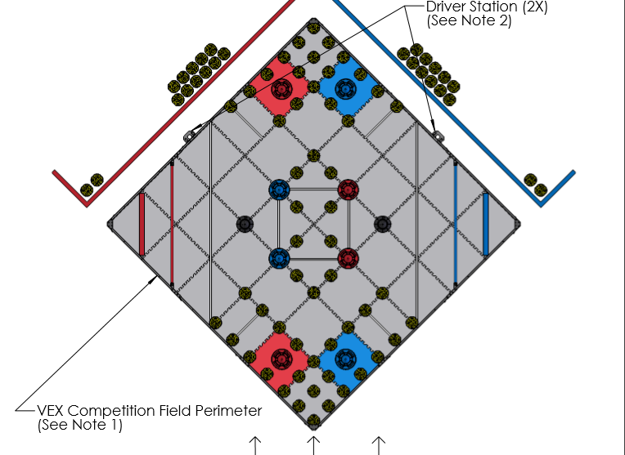Point breakdown:

**Autonomous:** 10pt

**Win:** 10

**Cones:** 160pt

**On field: (**26*2) * (2)

**Preload: (**2*2) * (2)

**Driver Load: (**12*2) * (2)

**Mobile goals:** 50pt

**20pt Zone:** 1*(20)

**10pt Zone:** 3* (10)

**Highest stack:** 15pt

**20pt Zone:** 5

**10pt Zone:** 5

**Stationary Goal:** 5

**Park Bonus**: 4pt

**Team square:** 2*(2)

***Total:*** *239*

# Max possible points

**Assuming the opposition is helping.**

# Max points in equal division

**Max points when field cones are split between two teams**

**Autonomous:** 10pt

**Win:** 10

**Cones:** 80pt

**On Field:** 26 * (2)

**Preload**: 2 * (2)

**Driver load:** 12 * (2)

**Mobile goals:** 50pt

**20pt Zone:** 1*(20)

**10pt Zone:** 3* (10)

**Highest stack:** 15pt

**20pt Zone:** 5

**10pt Zone:** 5

**Stationary Goal:** 5

**Park Bonus**: 4pt

**Team square:** 2*(2)

***Total:*** *159*

**Note:** It is not worth the effort of putting a Mobile Goal in the 5pt zone as assuming you get highest stack in the 5pt zone 50% of the time it is only worth 7.5 points compared to putting in the 10-point stack where it is always worth 10 points.

## Target: 159pt

By looking at the high score breakdown we have decided our score target for the end of the season is 159pt

Point Breakdown

|  |  |  |  |  |  |  |
| --- | --- | --- | --- | --- | --- | --- |
| **Category** | **Name** | **Individual points** | **Amount** | **Overall points** | **Percentage** | **Difficulty** |
| Autonomous | Win | 10 | 1 | 10 | 6.29% |  |
| Cones | On Field | 2 | 26 | 52 | 32.70% |  |
| Preload | 2 | 2 | 4 | 2.52% |  |
| Driver Load | 2 | 12 | 24 | 15.09% |  |
| Mobile Goal | 20pt Zone | 20 | 1 | 20 | 12.58% |  |
| 10pt Zone | 10 | 3 | 30 | 18.87% |  |
| Highest Stack | 20pt Zone | 5 | 1 | 5 | 3.14% |  |
| 10pt Zone | 5 | 1 | 5 | 3.14% |  |
| Static Goal | 5 | 1 | 5 | 3.14% |  |
| Park Bonus | Team square | 2 | 2 | 4 | 2.52% |  |
| **Total** | **Everything** |  |  | **159** | **100%** |  |
| Autonomous | All | 10 | 1 | 10 | 6.29% |  |
| Cones | All | 2 | 40 | 80 | 50.31% |  |
| Mobile Goal | All |  |  | 50 | 31.45% |  |
| Highest Stack | All | 5 | 3 | 15 | 9.43% |  |
| Park Bonus | All | 2 | 2 | 4 | 2.52% |  |

To be written.

# Analysis